C:\Users\st11223\Desktop\MIT LOGO ETC\New MIT Logo.png

**NEW ZEALAND MARITIME SCHOOL**

**NZ Diploma in Marine Electro-technology (NZ2894)**

**(STCW 1978 A-III/6, as amended in 2010)**

**Electro-Technical Officer, Year 2 Cadets, 2020.**

**Course Code**

942.644 – AS01/PC01.

**Course Title**

Maintenance and Repair of Electrical, Electronic and Control Systems of Deck Machinery and Cargo Handling Equipment.

Learning Outcomes and Practical Assessment.

**Format**

Written assignment of 1500 words including diagrams and marked Competent (C) or Not-Yet Competent (NYC). Weighting = 50%.

**Due Date**

To be submitted by email to [nick.cossar@manukau.ac.nz](mailto:nick.cossar@manukau.ac.nz) for the due date of 19/07/2020.

**Tutor**

Nick Cossar

[nick.cossar@manukau.ac.nz](mailto:nick.cossar@manukau.ac.nz)

**Student Name:** Levi Dubbelman

**Student ID:** 190000929

**Date:** 18/07/2020

Describe the purpose and operation of the Safe Load Indicator on a modern ship’s crane as per Learning Outcome 2: principles required for leading the maintenance and repair of electrical, electronic and control systems of cargo-handling equipment. Include in the description any electrical/electronic components and method of operation.

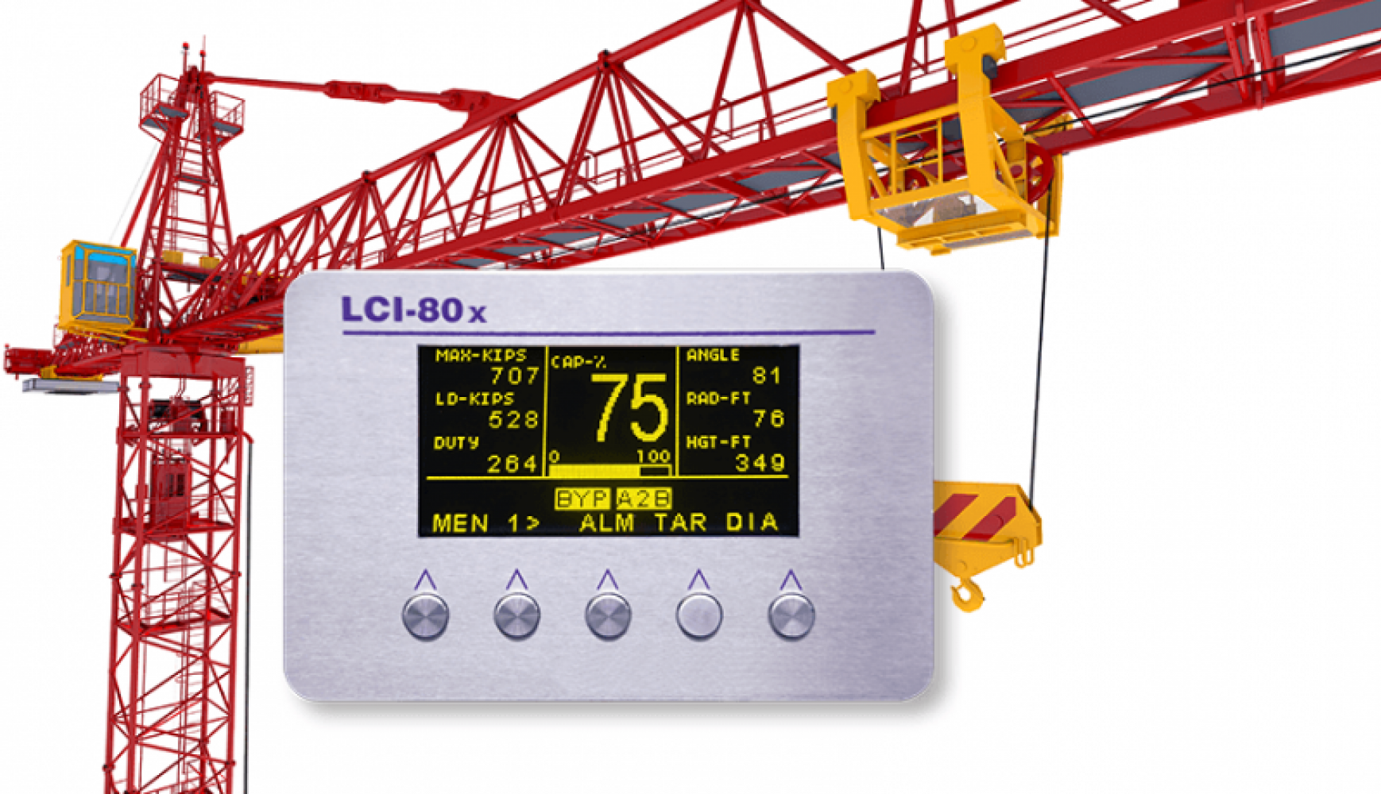

Safe load Indicators (SWL or SLI) calculate the force applied by the load on the crane and compare it with the design specifications of the crane. This prevents the driver from performing a manoeuvre (slew, hoist, luff etc.) which would exceed the maximum safe working load of the crane.

In addition to preventing an illegal manoeuvre, the SLI also allows the driver to see the force being applied, the angle, and the heights-over-ground of the hook.

The SLI is typically a PLC with several analogue and digital inputs feeding an HMI within the driver’s cabin. The sensors which send data to the SLI include:

* Load cells located at various points on the crane, for hook load sensing, outrigger load sensing, torsion / boom side load sensing, and counterweight information
* Rotary encoder, or other system for measuring the velocity of the load on the Z (vertical) axis
* Position sensors for the jack position and boom angle

The primary PLC of the crane will also take into consideration various temperatures for hydraulic oil and fire suppression sensing, in addition to several limit switches for end of travel.

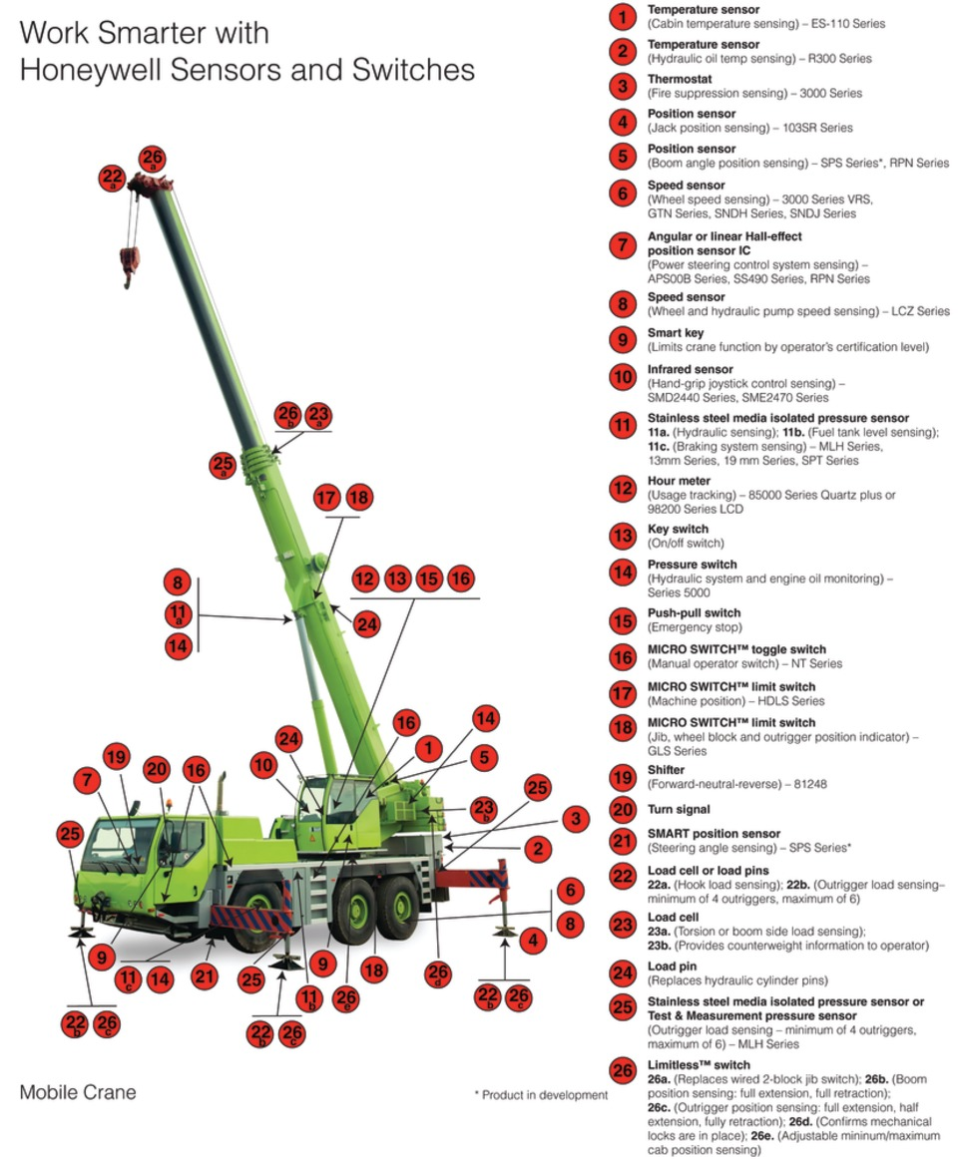

Describe the types of instruments used (such as multi-meters, calibrators and any other instruments) to assist with locating faults in the Safe Load Indicator along with the types of signals and information expected.

**Initial Diagnostics**

As with any initial diagnostics on faulty equipment, a multimeter can eliminate several faults very quickly. Using the multimeter on Volts AC or DC (situational) to check if there is power available on the unit to rule out a problematic power supply, a faulty or loose wire or errant power switch.

Using a thermal imaging gun or multimeter thermocouple while the device is operational or if a circuit breaker as tripped on thermal overload may help detect if a clogged fan filter, faulty wire, or excessive ambient temperature is causing overheating.

A multimeter placed in series with the power supply (not recommended) or a clamp meter will also help detect overheating as well as excessive current.

Voltages, temperatures, and current information will be likely located inside the technical specifications for the SLI, which will help in understanding information expected.

**General Diagnostics**

After the initial look into the device, a more directed approach may require the tightening of terminals within the device or checking for loose/chipped/broken solder pieces once the device has been de-energized and the relevant breaker opened. A multimeter on continuity setting may assist with this.

A multimeter will also allow for probing of the PLC inputs and outputs. This would enable you to check, non-invasively, the state of various Boolean sensors such as limit switches and will allow you to check voltage-based analogue sensors. For current based (0-20, 4-20mA) sensors, a milliamp clamp meter is highly recommended. Although it should be noted that if a 4-20mA sensor was reading <4 mA an alarm for this *should* be displayed.

**Specific Diagnostics**

When doing more intensive diagnostics, i.e. when the general cause of the fault has been located, specialist instruments may be employed, such as a high voltage insulation resistance tester (Megger) for insulation breakdown (although the device may be harmed by the high voltage, therefore care should be taken with proper isolation / probing).

Direct communication with the PLC may be necessary to check setpoints. A laptop with the relevant PLC company’s software can be used to do this, although it will likely require a password to access.

Direct probing of the printed circuit board may also be required if swapping is not an option. A multimeter on continuity, diode-test or capacitance test will assist with locating an errant component.

Explain principles of routine inspection, maintenance and repair of deck cranes equipment, with specific reference to:

* + **power supply (slip ring unit)**

**Inspection**

* Excessive scratching/pitting along the slip rings
* Excessive wear on carbon brushes
* Balanced load amongst brush connections
* Excessive build-up of carbon dust on slip rings

**Maintenance**

* Possible replacement or readjustment of carbon brushes
* Cleaning of slip rings

**Repair**

* Replacement of carbon brushes
* Replacement/refinishing of slip rings
  + **cabling and grounding**

**Inspection**

* Visible kinks / insulation breakdown / ruptures
* Terminal tightening
* Visible corrosion or physical damage
* Check for terminals/earthing points being unintentionally painted

**Maintenance**

* Tightening/cleaning of terminals
* Insulation breakdown (IR) testing with HVIR tester (MEGGER)

**Repair**

* Re-run of relevant cable with attention paid to fault; larger cable size may be necessary
* Replacement of terminals
  + **switchboards, terminal strips and connectors**

**Inspection**

* Visible damage to busbars, terminal strips or terminals
* Excessive dust build up on busbar
* Corrosion within terminal strips
* Loose plugs / connectors / terminals
* Excessive heat (IR gun/camera readings) during operation
* Imbalance of currents of each phase
* Earth faults

**Maintenance**

* Cleaning/re-tightening of terminal strips
* Cleaning/refinishing of busbar
* Replacement of loose connectors

**Repair**

* Refinishing of busbars
* Replacement of terminal strips, cabling, switchboard exterior if necessary
  + **control panels**

**Inspection**

* Cross-checking if data is accurate
* Mistaken zero/spanning of indicators or gauges
* Backlight bulb/dimmer checking
* Damage to buttons / sticky controls
* Accurate stick/HOTAS control calibration
* Removed, scratched out, damaged, broken off labels and indicators

**Maintenance**

* Replacement of bulbs
* Tightening/cleaning of terminals, connectors
* Recalibration of stick / potentiometer controlled inputs
* Re-labelling of controls
* Removal of operator “additions”

**Repair**

* Replacement of buttons
* Replacement/repair of power supplies
* Replacement/recalibration/repair of HOTAS controls
  + **PLC outputs and inputs**

**Inspection**

* Confirmation outputs and inputs are receiving/sending correct values
* Excessive corrosion on terminals
* Loose terminals

**Maintenance**

* Tightening/cleaning of terminals
* Recalibration of sensors

**Repair**

* Replacement of PLC and relevant software
* Replacement of sensors
  + **electrical motors and brakes**

**Inspection**

* Excessive wear on brakes
* Signs of motor overheating
* Signs of water or dust ingress
* Smoke/burning smell
* Physical damage or corrosion

**Maintenance**

* Replacement of brake pads
* Cleaning of stator windings if necessary
* HVIR (MEGGER) testing for insulation breakdown
* Balanced current on incoming phases
* Excessive voltage drop on motor/brakes

**Repair**

* Re-winding or replacement of motor and brakes
  + **power electronic converters**

**Inspection**

* Software interrogation via panel
* Signs of damage, corrosion, overheating
* Ruptured capacitors, diodes

**Maintenance**

* Tightening of terminals

**Repair**

* Replacement of unit
  + **limit switches**

**Inspection**

* Checking correct on/off behaviour
* Visible damage/crushing of switch actuator
* Visible damage of housing
* Loose/’wobbly’ mounting
* ‘Sticky’ actuator

**Maintenance**

* Greasing/lubrication of actuator
* Tightening/cleaning of terminals

**Repair**

* Replacement of switch
  + **safety devices**

**Inspection**

* Compliance with SOLAS/Registry requirements
* Physical damage, excessive wear

**Maintenance**

* Re-calibration

**Repair**

* Replacement of device
  + **electric control of hydraulic pumps, motors and brakes**

**Inspection**

* Excessive/imbalanced currents
* Physical damage or corrosion
* Worn brake pads
* Low hydraulic oil levels
* Damage/cracking/bleeding of hydraulic lines
* Excessive hydraulic oil pressure

**Maintenance**

* Replacement of brake pads
* Re-calibration of sight glass / pressure sensors / tank level sensors
* Tightening of terminals

**Repair**

* Replacement of controllers
* Replacement of local/remote controls
* Replacement of power/control cabling
  + **electric control of grabs, container spreaders and other cargo lifting facilities**

**Inspection**

* Incorrect operation (excessive force/torque; jerky controls)
* Excessive currents
* Incorrect sensor data (e.g. load cell)

**Maintenance**

* Recalibration of sensors using known weight
* Tightening/cleaning of terminals

**Repair**

* Replacement of controllers
* Replacement of local/remote controls
* Replacement of power/control cabling
  + **ventilation and heating**

**Inspection**

* Dirty filters
* Earth fault on heating
* Correct refrigerant levels

**Maintenance**

* Replacement of filters
* Topping up or release of refrigerant
* Replacement of seals
* Cleaning of heating elements

**Repair**

* Replacement of compressor/heating elements